

Figure S1. Alignment reconstructions of candidate transporters from Aiptasia and other higher model organisms. Selected epitopic regions are shown with green annotations.



Figure S2. Confocal examination for symbionts presence by chlorophyll autofluorescence, (A) fully aposymbiotic anemones before the inoculation. (B) B. minutum, (C) D. trenchii, (D) S. microadriaticum and (E) aposymbiotc control by the end of the experiment.



Figure S3. Number Colonization success rate was different in between symbionts. The number of symbionts per host mg protein was significantly higher in anemone colonized by B. minutum (p <0.05). Error bars are showing ± SE.



Figure S4. Expression of transporters detected by immunoblotting in symbiotic and aposymbiotic Aiptasia and symbionts. 30 µg total protein of each sample was loaded on each well separately. Pre-adsorption specificity controls (PB) with 2x concentration of peptide antigen, pre-immune serum controls and secondary antibody (Goat Anti-Rabbit IgG AlexaFluor®555) controls are also shown where possible. All the transporters were detected at expected molecular weight (A) AMT1 51 kDa, (B) GLUT8 55 kDa, (C) AQP 22 kDA and (D) V-Type ATPase 55 kDa.

A

B

C

D

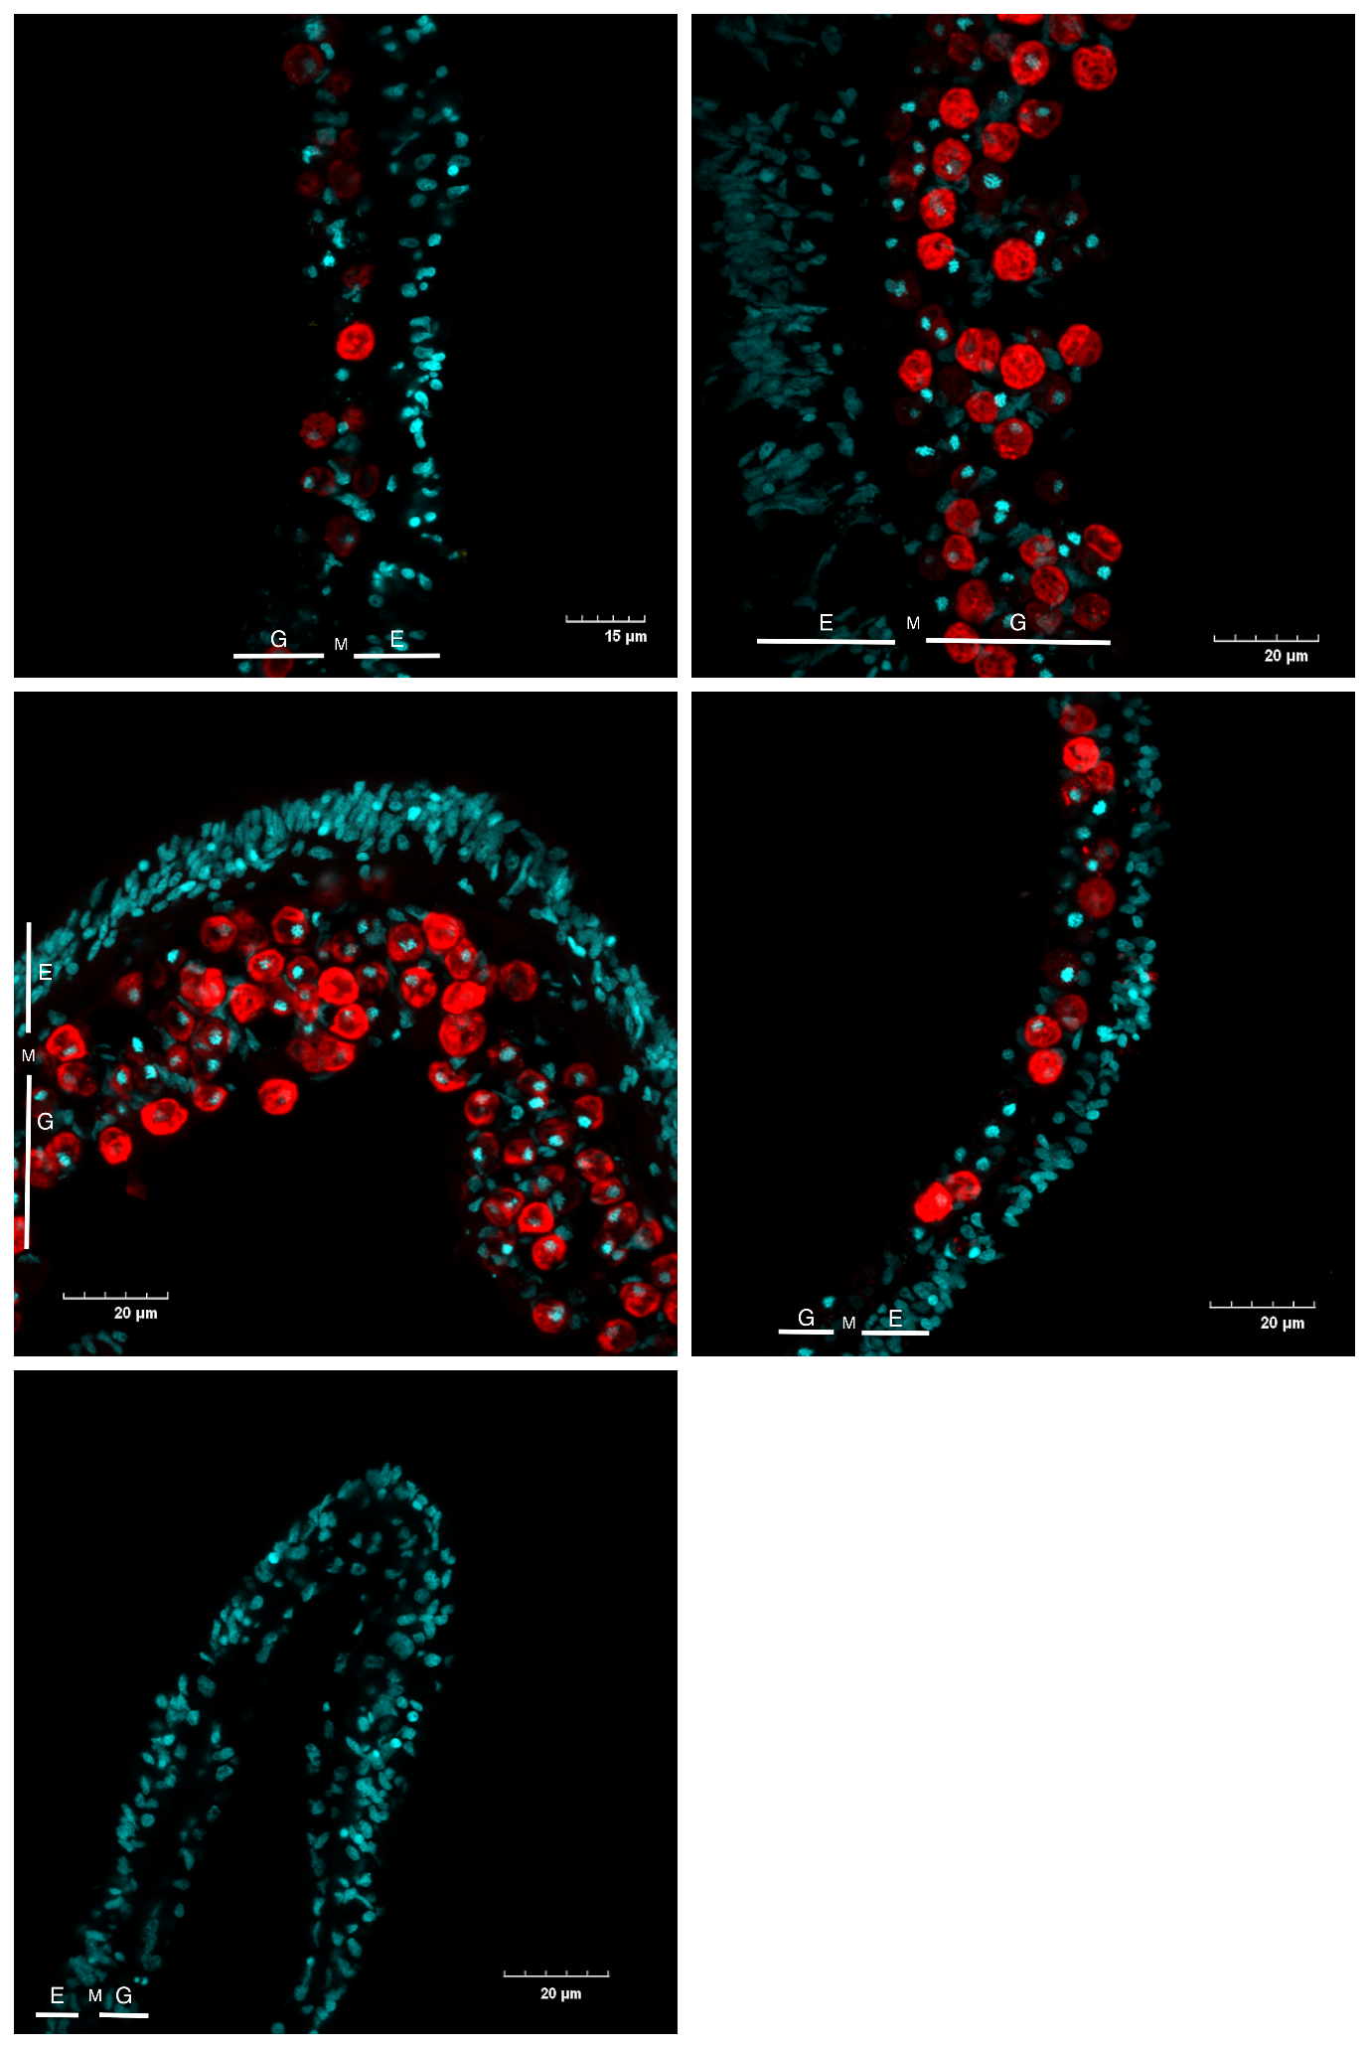

Figure S5. Immunolocalization controls. Peptide antigen pre-adsorption of (A) anti‐AMT1, (B) anti‐GLUT8 and (C) anti‐AQP. (D) and (E) Secondary antibody controls of symbiotic and aposymbiotic host, respectively.

A

B

C

D

E

Figure S6. Scanning electron microscopy micrograph of symbiotic Aiptasia gastrodermal cell using freeze-fracture technique. (A) host and symbiont inside symbiosome membrane complex. (B) The interface of symbiosome complex and symbiont cellular organelles. hm, host membrane; sm, symbiont; smp, symbiosome membrane complex; chl, chloroplast. The void spaces are places for other cytoplasmic organelles (e.g. nucleus, mitochondria) of host and symbiont, both of which were remove by freeze-fracture technique.



A

B

chl

hm

sm

smp

hm

hm

smp